EXP 8 : PERFORMANCE ANALYSIS OF FM SYSTEM UNDER GAUSSIAN WHITE NOISE USING MATLAB

SOFTWARE USED : MATLAB SOFTWARE

CODE :
clc; clear; close all

Fs=1e5; t=0:1/Fs:5e-3;
fm=1e3; fc=10e3; beta=5;
m=cos(2*pi*fm*t);

FM=fmmod(m,fc,Fs,beta*fm);
rx=awgn(FM,10,'measured'); % AWGN channel
d=fmdemod(rx,fc,Fs,beta*fm); % FM demodulation

subplot(4,1,1),plot(t,m),title('Message Signal'),grid on
subplot(4,1,2),plot(t,FM),title('FM Signal'),grid on
subplot(4,1,3),plot(t,rx),title('FM Signal with AWGN'),grid on
subplot(4,1,4),plot(t,d),title('Demodulated Signal'),grid on

fprintf('SNR = 10 dB\n');
fprintf('MSE = %.4f\n',mean((m-d).^2));

MODEL GRAPH :
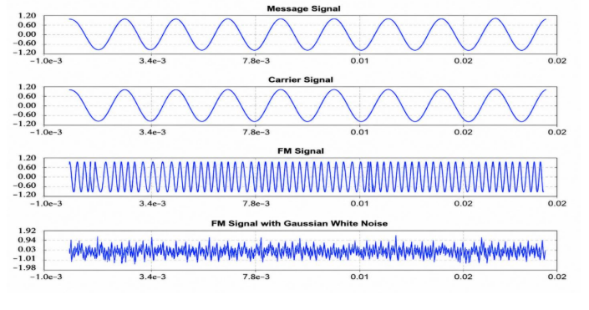
RESULT :
